Chapter 3 RESEARCH FINDINGS

3.1 Experiment Results

30 observations were monitored during the experiment about data breaches on Basic, Secure Socket Layer, and Transport Layer Security connections. The algorithms for each connection produce different results. I can conclude that connections would produce more breaches if the encryptions complexities are simpler.

* + 1. Materials and Procedures

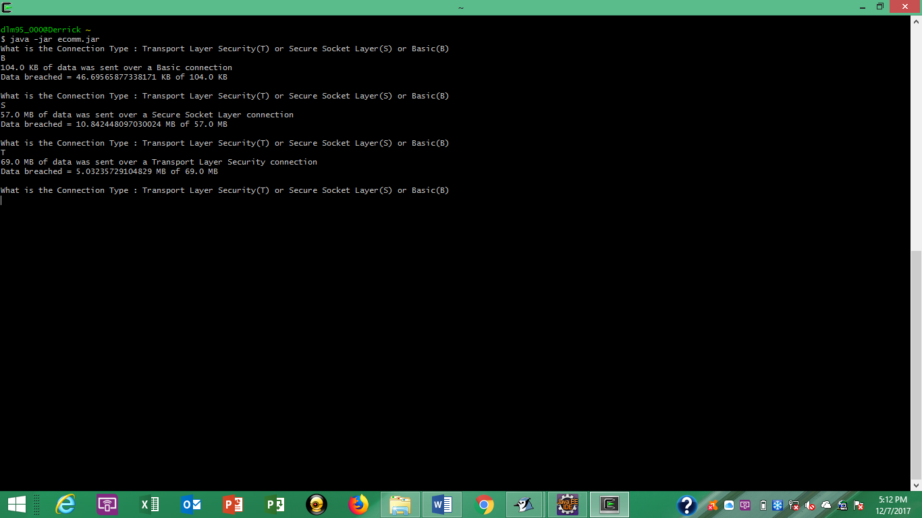In order to perform the experiment a Java installation must be installed on your system and you must obtain the java code that contains the e-commerce breach simulation. Once you have initiated the installation follow the directions of the prompts and ensure the everything meets your system requirements. Next, the Java code that makes the program has to be entered into a Java programming platform. Then, the code must be compiled and executed. Once running you will be prompted to type the first letter of the connection being used during transport. Lastly, the program output the results.

* + 1. Comparison to Related Work

In my research I came across other simulator that calculated data loss as well. The algorithms used in the compared work were not visible to create an exact match. Thus, my project contained algorithms that would produce common results. In my work I developed a simulation of data loss using the varying connection types used by e-commerce platforms. As a result of the simulation users should have a respectable understanding of the protection of information delivered through e-commerce connections.

3.2 Data Analysis Results

Graphs were used to provide a visual of the calculations returned from the experiment. With the growth of e-commerce marketplaces, it is valuable to understand the risks of engaging with these forms of market. This experiment was developed to measure the breach information regarding to the security of connecting the network in an e-commerce infrastructure.

3.2.1 Descriptive Data Analysis

The descriptive data analyzes the breach total for various data sizes. Analysis for Basic, Secure Socket Layer, and Transport Socket Layer connections were observed. The information is depicted on a scatter plot from the lowest data size of 50 MB to 250MB. Each connection type has a corresponding color that represents its’ value. The results are described using exponential lines to understand the trend of the different possible outcomes.

3.2.2 Hypothesis Test Data Analysis

The hypothesis test data was analyzed using a T-test. The values calculated are the mean, standard deviation, variance, count of observations(N), T-Value (Basic-SSL), and P-values (for Basic-SSL and TLS-SSL). The test found the P-value was lower than 0.05. This correlates to the probability of the observed results are random due to chance are low. Concluding the Null hypothesis is denied following the results.

3.3 Discussion Findings

As a result of the research conducted I came across much interesting information. There were products that could be purchased by people who wanted to start an e-commerce marketplace. The products contained the necessary tools to run a proper e-commerce platform. These also included the security features that would protect everyone accessing and using the platform. I learned the different characteristics that should be incorporated in a comprehensive e-commerce system.